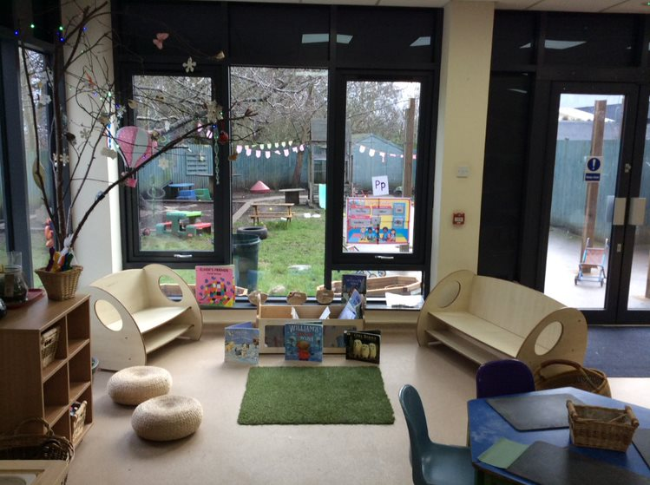

Nursery@B63

Information Handbook

Welcome to Nursery@B63

We are the Nursery staff:

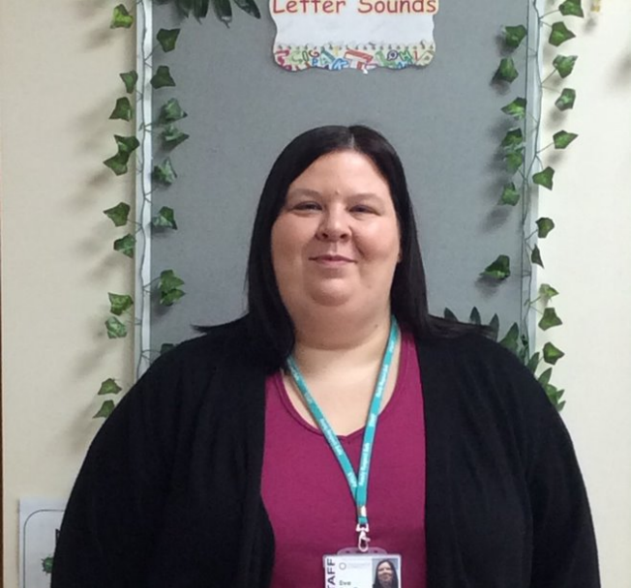
Mrs Eve Bradley
Manager/DSL

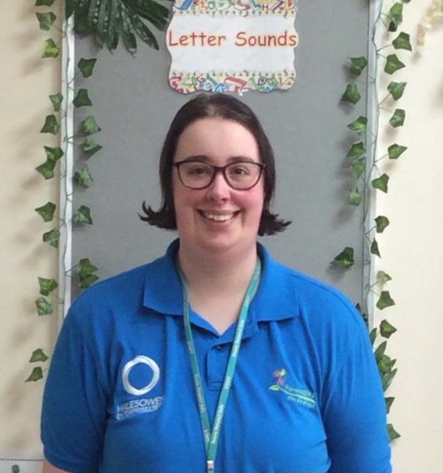
Mrs Sarah-Jane Cree Miss Natalie Davies
Deputy Manager/SENCO Third in charge
Health and safety officer

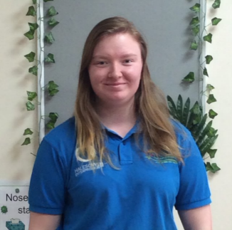
Rebecca Glaze
Baby Room Practitioner Early Talk co-ordinator
Kerry Roper
Main Room Practitioner
SEN support adviser
Mrs Hayley Dancer
Main room Leader
Student liaison officer

Sophie Hunter
Main Room Practitioner
Welcomm support adviser
Mrs Jennifer Belt
Baby room Leader Positive Behaviour co-ordinator
Victoria Newson
Baby/Main room practitioner
PSED adviser

Zoe Dell
Casual Nursery Nurse Cover

We welcome you and your child to
Nursery@B63 and hope that your child will be happy here.
Our address and telephone numbers are:
Address:
Nursery:
Halesowen College:
email- nursery@halesowen.ac.uk

Welcome To our Nursery Provision.
We appreciate that starting an early year's provision is a big step for both you and your child. We aim to make this a happy one, where your child will enjoy a caring, stimulating environment, where they feel secure and confident, able to learn through enjoyment and challenge and comfortable to share and communicate with both staff and their peers.

We operate a staggered intake system, whereby children are admitted as and when a parent/carer requires. You will be invited to stay and support your child during their induction visits into the provision.
We consider the partnership between children, parents, and staff to be fundamental in the development of your child.
We like to keep you informed about what the children are covering in their learning, through regular newsletters and updates on Tapestry, giving information on topics and planned activities throughout the year.

Staff are always available to discuss any concerns or problems that may arise, please do not hesitate to approach us. We operate an open-door policy as required or contact us by email or telephone to request an appointment.
The staff are available for a short period of time before and after sessions and will make every effort to see you if possible.

All policies are available upon request and parents will be supplied with copies of vital information.

Admissions
In the allocation of places, priority will be given to the children of
- students who might otherwise have to abandon their course.
- staff working at the College.
- Vulnerable children and families, allocation from outside agencies, families that come under the LAC criteria and families on a low household income that claim for their childcare provision (time for twos).
- Members of the local community and applications and enquiries are welcome.

Children numbers will be strictly regulated so that the maximum legally permitted number is not exceeded.

Prior to a child’s attendance at the Nursery the parents or carers must complete and sign the contract and registration forms.

This provides the Nursery with the following vital information:
- Name, home address and date of birth of child
- Starting date and number of sessions per week required
- Name, address and telephone numbers of parents or carers
- Emergency contact telephone numbers
- Any special dietary requirements and/or allergies
- Name, address and telephone numbers of the child’s doctor
- Health development checks and immunisation details
- Child’s religion and language spoken at home
- Parental consent on emergency procedures
- Parental consent on trips/outings
- Named people to collect child and password procedures.
- Tapestry consent.
- Safeguard consent.
- Parental responsibility and who has legal contact with the child
- Parental consent form in Early Years provision for the use of photographs, videos, or web
Parents or carers will also be asked to provide the Nursery with any further information which they feel will enable staff to take the best care of their child. This should include likes and dislikes in food, feeding habits and dummy/comforter use.

Opening Hours
Nursery@B63 provides care for children during the following hours:
Monday to Thursday 8.00am to 5.30pm
Friday 8.00am to 5.00pm

Fees
Morning with a snack and lunch provided.
Monday to Friday 8am — 1pm
£32.00

Afternoon with lunch and light tea provided.
Monday to Thursday 1pm — 5:30pm
Friday 1pm — 5:30pm
£29.00

All day with snack, lunch and light tea provided.
Monday to Thursday 8am — 5:30pm
Friday 8am — 5pm
£49.50

*Discounts are available for parents that pay for a full week, please enquire about this discount with the Nursery Manager.

What will my child need?
Your child will need to bring a water bottle with them every day.
A bag with changes of clothes, nappies, wet wipes and nappy cream. Please make sure these are labelled with their name.
Their comforter e.g. a blanket or a dummy.
Early Years Foundation Stage

Every child deserves the best possible start in life and the support that enables them to fulfil their potential. Children develop quickly in the early years and a child’s experiences between birth and age five have a major impact on their future life chances. A secure, safe, and happy childhood is important. Good parenting and high-
quality early learning together provide the foundation children need to make the most of their abilities and talents as they grow up.
Department of Education.

The Areas of Learning and Development
We offer our children a broad and balanced Early Years Foundation Stage (EYFS) curriculum.
- Communication and Language
- Physical Development
- Personal, Social and Emotional Development
- Literacy
- Mathematics
- Understanding of the World
- Expressive Arts and Design

Staff consider the individual needs, interests and stage of development of each child in their care and use this information to plan a challenging and enjoyable experience for each child in all areas of learning and development. We focus primarily on the Prime Areas of Personal, Social and Emotional development, Communication and Language and Physical Development.

Learning through Play
Each area of learning and development is implemented through planned, purposeful play and through a mix of adult-led and child-initiated activity. Play is essential for children’s development, building their confidence as they learn to explore, to think about problems, and relate to others. Children learn by leading their own play, and by taking part in play which is guided by adults.

Outdoor Learning
The children have access to the outdoor area every day. Being outdoors has a positive impact on children's sense of well-being and helps all aspects of children's development. It offers opportunities for doing things in diverse ways and on different scales than when indoors.
It gives children first-hand contact with weather, seasons, and the natural world. Our outdoor environment offers children freedom to explore, use their senses, and be physically active.

Children need to bring Wellington Boots (named) and these can be stored in the provision. A coat and appropriate clothing will be needed.

Behaviour
Even the youngest children are encouraged to behave towards each other with kindness and consideration.
We praise the children for all their achievements and give rewards in the form of verbal praise, stickers, and certificates.
The Behaviour Co-ordinator for the Nursery is Jennifier Belt.

Key Person
Each child is assigned a Key Person. Their role is to help ensure that every child’s care is tailored to meet their individual needs, to help the child become familiar with the setting, offer a settled relationship for the child, and build a relationship with their parents.

Learning Journeys
Learning Journeys are used to record your child’s achievements. The electronic Learning Journeys provide us with information to help us to form judgements on your child’s interests and progress, allowing us to create more relevant and meaningful learning experiences within the nursery.
We will offer you opportunities to come into the provision to view your child’s electronic Learning Journey and you will automatically be sent regular updates. This is a fantastic opportunity for you to see the activities and learning that your child has been involved in and a chance for them to take pride in showing you, their achievements.

Equal Opportunities
Nursery@B63 seeks to provide equality of opportunity and anti-discriminatory practice, ensuring that every child is included and supported.
Throughout the early years, if a child’s progress gives cause for concern, staff will discuss this with parents and/or carers and agree on how to support the child. Staff will consider whether a child may have a special

educational need or disability which requires specialist support. Nursery will link with, and help families to access, relevant services from other agencies as appropriate.
The Equal Opportunities and Special educational needs Co-ordinator for the Nursery is Sarah Cree.

Safeguarding Children and Child Protection
The provision has a duty of care in terms of Safeguarding and Child Protection issues.
The Nursery has an agreed policy and set of procedures for child protection in line with Dudley Safeguarding Children’s Board.

Designated Lead for Safeguarding and Child Protection is:
Eve Bradley
Deputy Designated safeguarding leads are Sarah Cree and Natalie Davies.

Maintaining a Safe and Secure Environment
The safety of the children is our highest priority. We will therefore
Only allow your child to go home with you, unless we have received your advance permission that he/she may be collected by another adult.
We ask all visitors to identify themselves and to state their business before we give them access to the premises. Visitors sign in, wear
visitor’s badges and are escorted throughout their visit. They sign out upon leaving the main reception before leaving the premises. We operate an Empty Pockets Policy.

How to Book
To enquire about a place please contact the Nursery Manager. There may be a waiting list so early booking is essential, especially for baby and toddler places (under 2 years).
Parents/carers are advised to visit Nursery@B63 with their child(ren), on several occasions for short introductory sessions before the child begins attending. No charge is made for the introductory sessions.
On receipt of a completed application, the Nursery Manager will check availability to ensure the requested days or sessions are available. The

parent/carer will then be issued a nursery contract. If the required days or sessions are unavailable the parent/carer may place the child on the waiting list, which operates on a ‘first come, first served’ basis.

Payment
A deposit of one week’s payment is requested to secure your child’s place and must be made within 4 weeks of an issued start date and prior to the completion of settling in sessions.
Fees are specified in the nursery contract and are payable by the 1st of each month.
Invoices are issued monthly in advance. The methods of payment are by BACS payment and/or childcare vouchers. We accept various childcare vouchers, which may be available from your employer. Vouchers are a financial benefit and are exempt from tax and national insurance payments, therefore the tax and national insurance amount is calculated after the voucher amount has been deducted from salary. The maximum amount which can be received in vouchers is £55 per week or £243 per month. Any top up must be paid by BACS payment.
Alternative payment methods may be agreed by the Safeguarding and
Inclusion Manager in exceptional circumstances.

On cessation of use of the nursery, the final month’s invoice will be paid to the value of the deposit with any subsequent invoice or refund actioned at this time.
Standard contracts are available from the Nursery Manager.

Funding and Support
We provide educational funding for two-year-olds (Time for Twos) and three and four-year-olds. This begins the term after your child’s second or third birthday for up to 15 hours free childcare a week (terms and conditions apply). We also provide 30-hour funding for working families that are eligible.

Students may be able to access financial support from Care to Learn or the College Discretionary Learner Support Fund. The contract remains between Halesowen College and the student who is liable for all fees and charges. Students will not need to make a deposit payment.
Should a parent/carer be in receipt of Early Years Funding or similar, the free hours claimed will be deducted from the monthly invoice.

Parking

We ask that parents park on car park A and sign in and out at the college's main reception. Additional parking is available in car park C but we must ask that you still report to reception for the health and safety on site.
Please find a dedicated parking space and do not park behind any other vehicle, the car parks can be congested during peak times.

Policies
Policy documents are available to view in the policy file which is situated in the provision. As policy’s change Parents will be updated regularly.
Parents can request an electronic or hard copy of any policy they require. A list of policies will be available in this information pack.

No Smoking
We operate a No Smoking policy across the whole Nursery site.

Asthma
If your child has asthma please ensure that all prescribed medication is given to the Manager and clearly labelled and in date. You will be required to complete an asthma form and a Care Plan if applicable.

Allergies
If your child suffers from any allergies please inform the Manager, a Care Plan may need to be completed.

Accident or Injury
A first aid box is always accessible, and staff keep a written record of all accidents or injuries and first aid treatment. Parents and/or carers will be informed of any accident or injury sustained by the child on the same day, or as soon as reasonably practicable, of any first aid treatment given.

In the case of a more serious injury, parents will be contacted using the emergency contact details provided.
Our health and safety officer is Natalie Davies.

Mealtimes
Mealtimes are a great, social experience for children and are great for focusing on their practical needs, Snack, Lunch and a light tea are available throughout the day. Some parents will bring their own from home, whereas others take up the opportunity to purchase food and drink from Nursery.

Typical Lunches
- Sausage casserole served with new potatoes.
- Chicken pie with a mashed potato topping
- Ham and broccoli pasta bake, served with pitta bread.
- Chicken curry with rice
- Sweet and sour chicken noodles with pitta bread
- Fruit, yoghurt, flapjacks and a variety of cakes
A vegetarian option is available upon request.
If your child has an intolerance or allergy, please inform the Nursery Manager.

Parents as Partners

Establishing a strong link and relationship between home and Nursery is vital to support and develop children’s learning. There will be many opportunities for parents/carers to contribute to Nursery life.

By taking the opportunity to support your child’s learning and working in partnership with the adults in the provision you can significantly influence your child’s learning. Your continued involvement is crucial to successful learning. We aim to make our parents feel welcome and valued.

Positive behaviour is promoted by praising and encouraging the children and being attentive to their needs. The value of parental input is recognised, and parents are encouraged to share, in their child’s learning.
Nursery@B63 strives to support the integration of children with specific or additional needs where this can reasonably be achieved and will implement focused interventions based on children’s specific needs.

Our Commitment to you:
- All parents/carers are welcome to visit the nursery at a time arranged with the nursery manager and will be offered the opportunity to work alongside their child’s key worker.
- Parents/carers will have access to their child’s records and will be consulted about the care given.
- Parents/carers will be informed about the policies, procedures and guidelines of the nursery. Requests for information can be made at anytime.
- There will be opportunities for involvement throughout the yearly curriculum, such as Open Events, Parents’ Evenings and invitations to join your child for fun parental sessions.
- Regular questionnaires will be sent to parents to monitor the quality of the service. An analysis of these questionnaires is sent to all parents.
- Parents/carers of a child in the baby room will receive a daily report detailing the child’s eating and sleeping patterns, fluid intake, toileting progress and information about the activities the child has taken part in that day on Tapestry. This is available for the main room at a parent’s request.
- The nursery team will work alongside parents/carers as partners in providing quality care for their children.

Contact Nursery!
Eve Bradley is the Nursery Manager and can be contacted by emailing nursery@halesowen.ac.uk or calling 0121 602 7677.

We look forward to welcoming you and your family to become part of our fun, exciting and fully inclusive Nursery@B63.

